- Top 10 strongest earthquakes (mag).
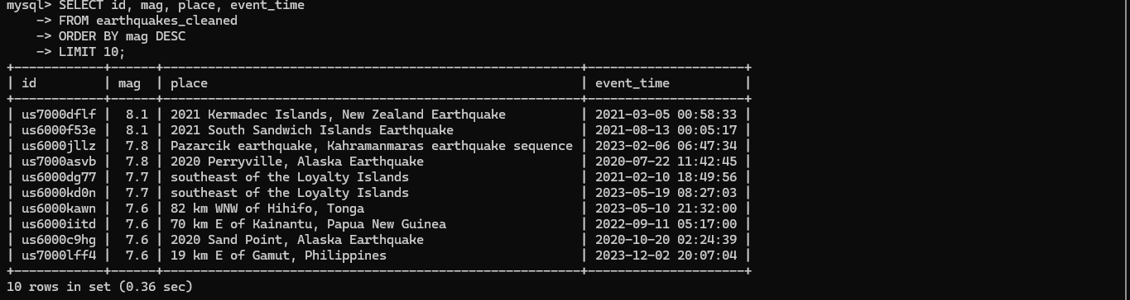
- Top 10 deepest earthquakes (depth_km)
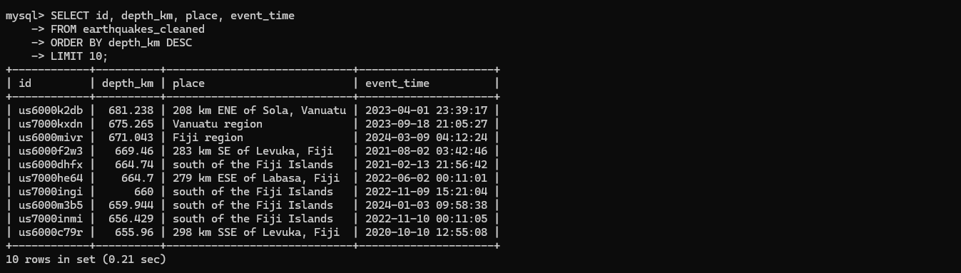

3. Shallow earthquakes < 50 km and mag > 7.5. 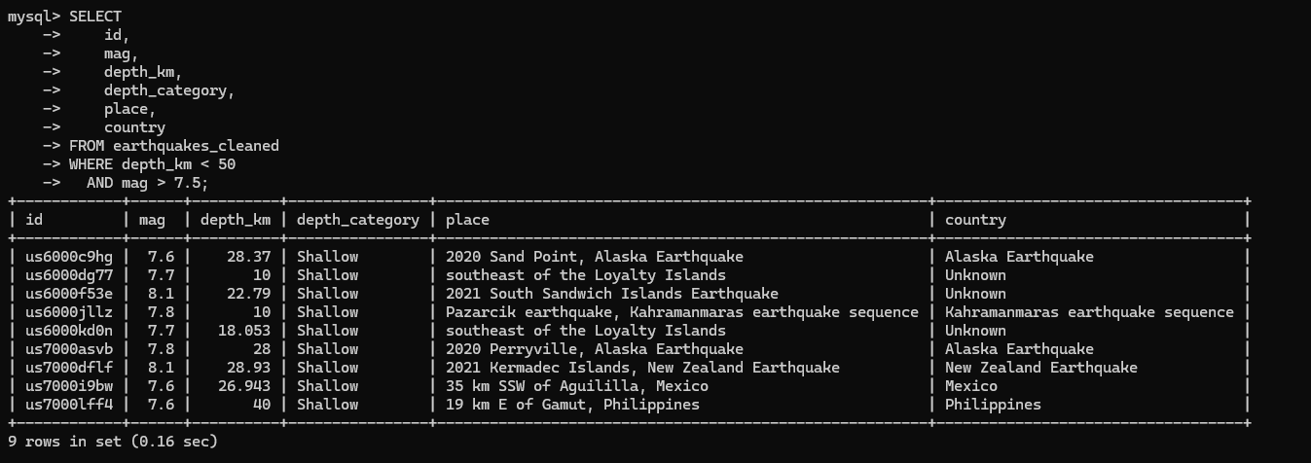
4. Average depth per continent.
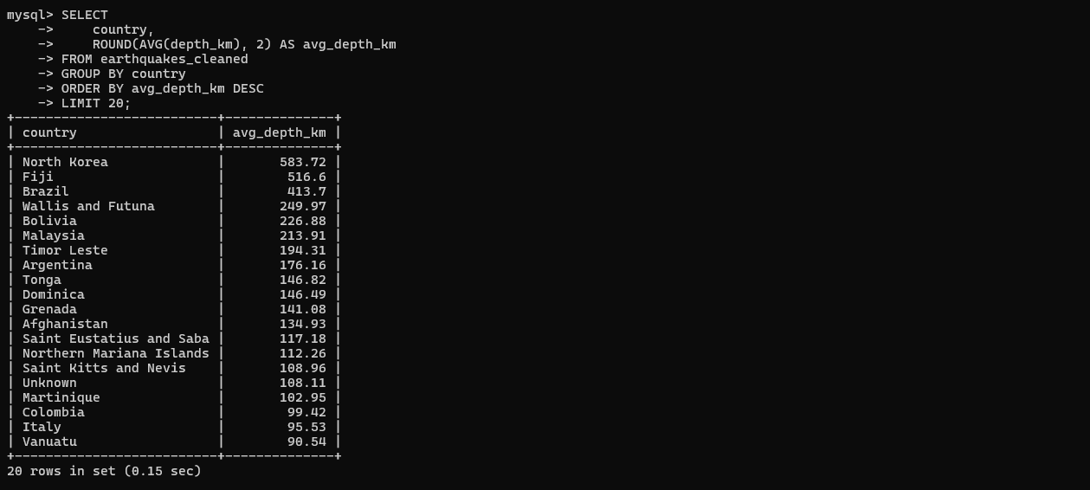

5. Average magnitude per magnitude type (magType)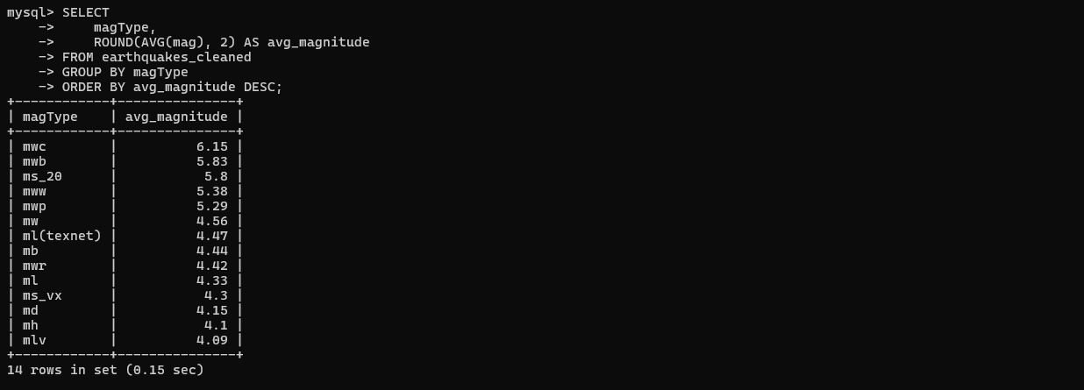
6. Year with most earthquakes.
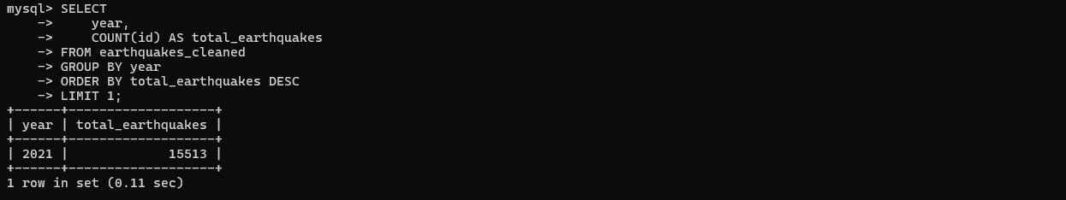
7. Month with highest number of earthquakes
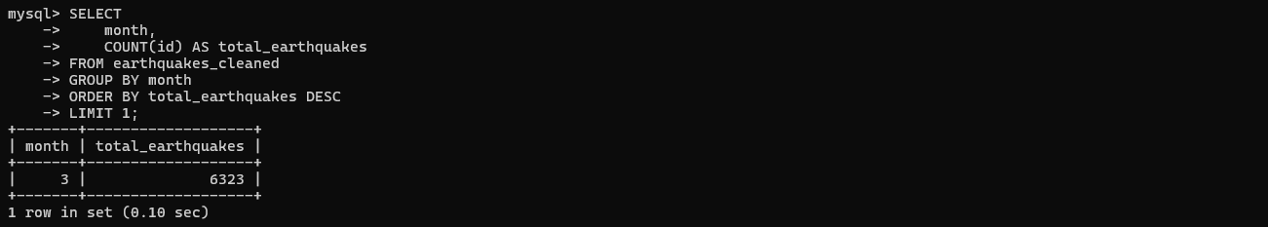

8. Day of week with most earthquakes. 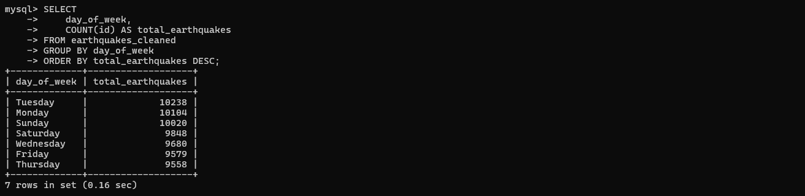
9. Count of earthquakes per hour of day.
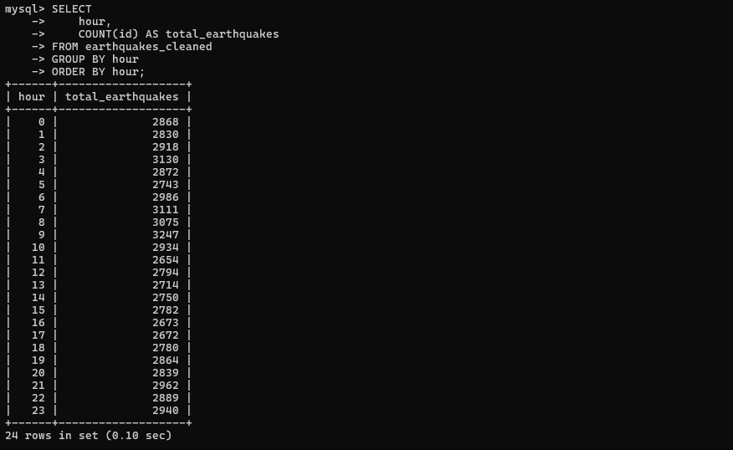
10. Most active reporting network (net).
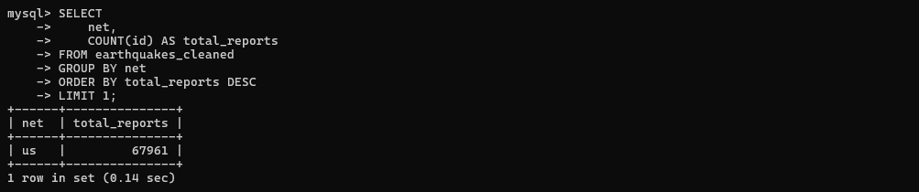
11. Top 5 places with highest casualties.
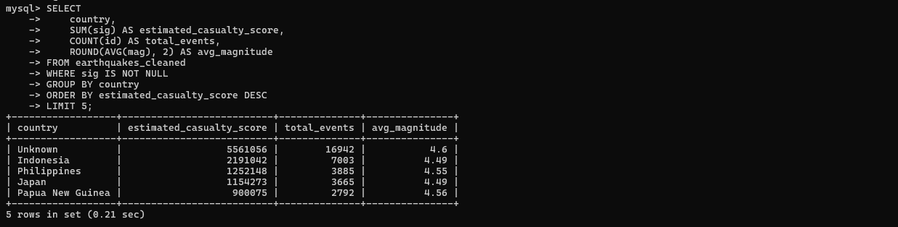

12. Total estimated economic loss per continent
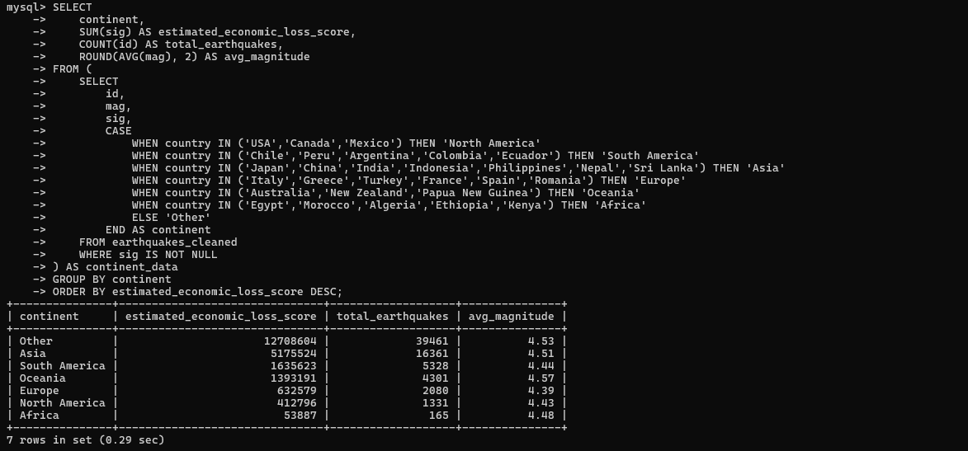

13. Average economic loss by alert level
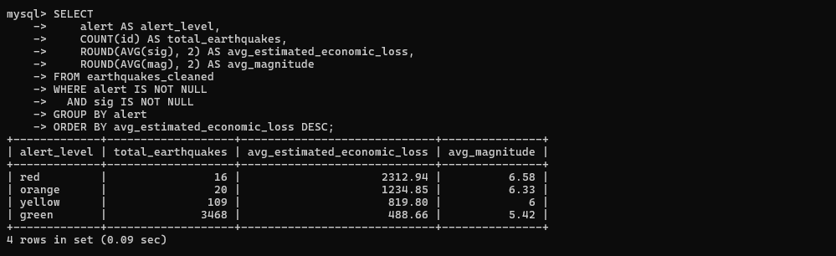
14. Count of reviewed vs automatic earthquakes (status)
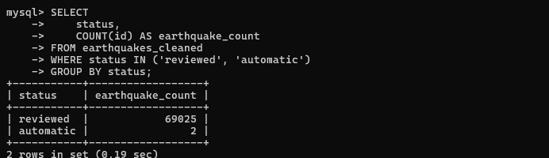

15. Count by earthquake type (type)
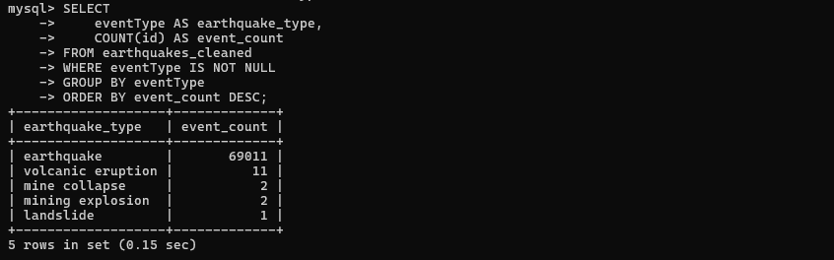

16. Number of earthquakes by data type (types)
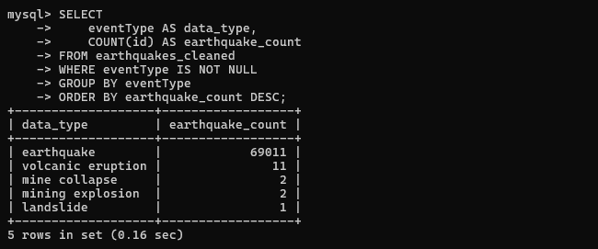
17. Average RMS and gap per continent
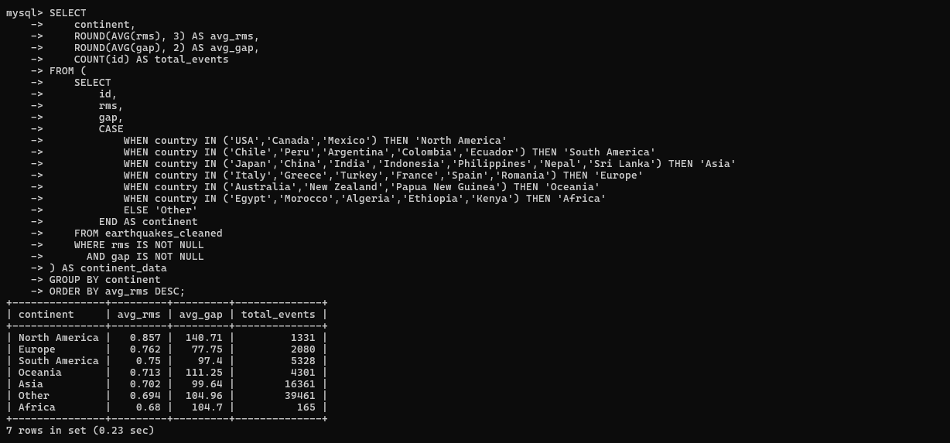

18. Events with high station coverage (nst > threshold).
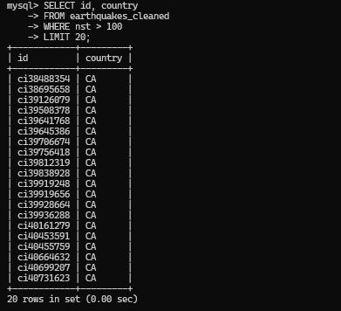

19. Number of tsunamis triggered per year
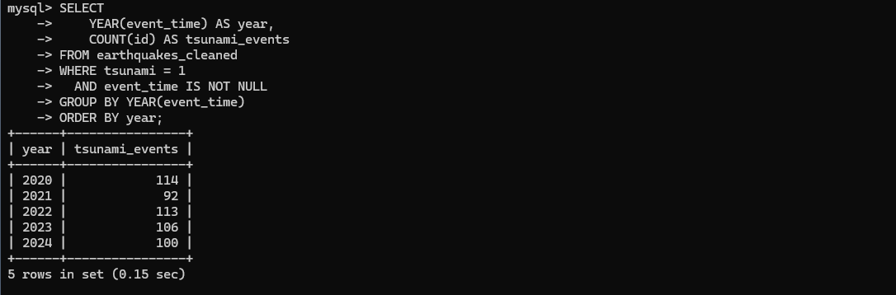

20. Count earthquakes by alert levels (red, orange, etc.)
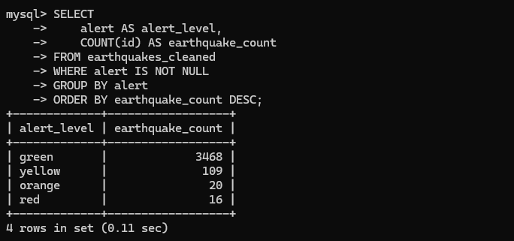

21.Find the top 5 countries with the highest average magnitude of earthquakes in the past 10 years
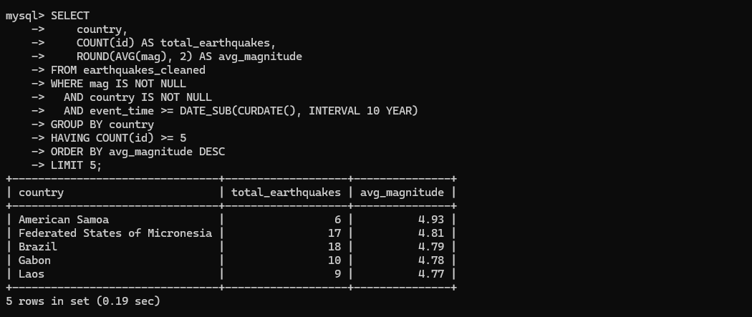

22.Find countries that have experienced both shallow and deep earthquakes within the same month.
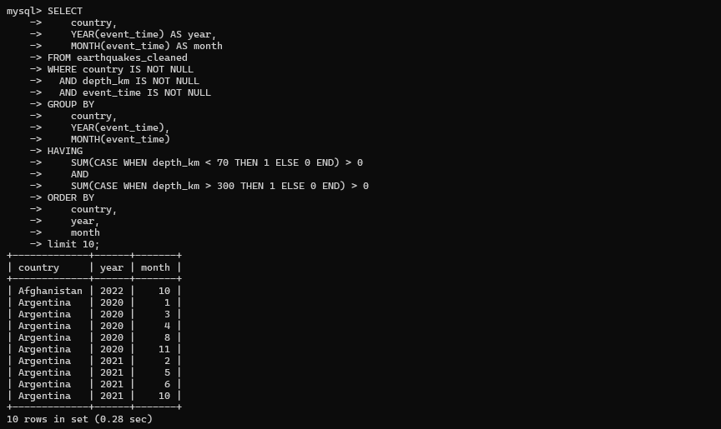

23.Compute the year-over-year growth rate in the total number of earthquakes globally.
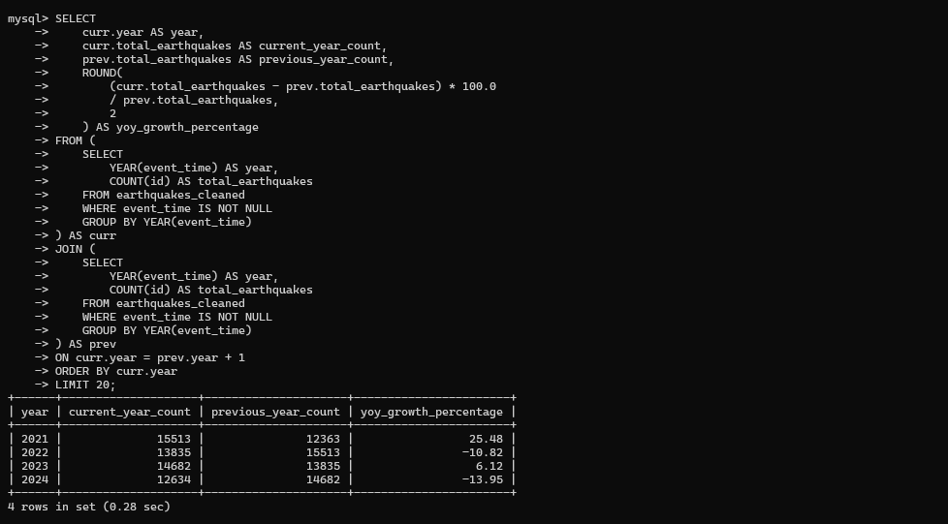
24. List the 3 most seismically active regions by combining both frequency and average magnitude.
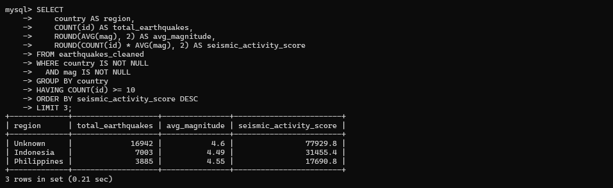

25. For each country, calculate the average depth of earthquakes within ±5° latitude range of the equator.
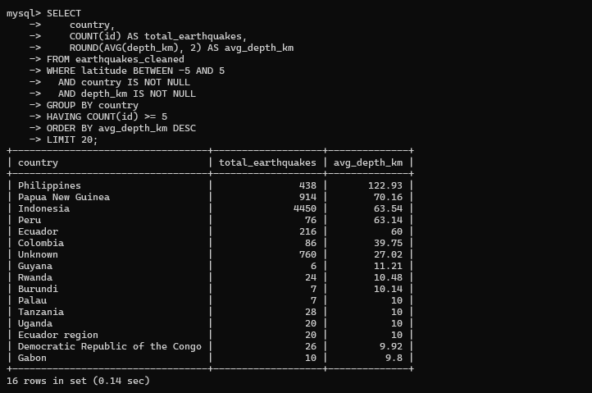

26. Identify countries having the highest ratio of shallow to deep earthquakes.
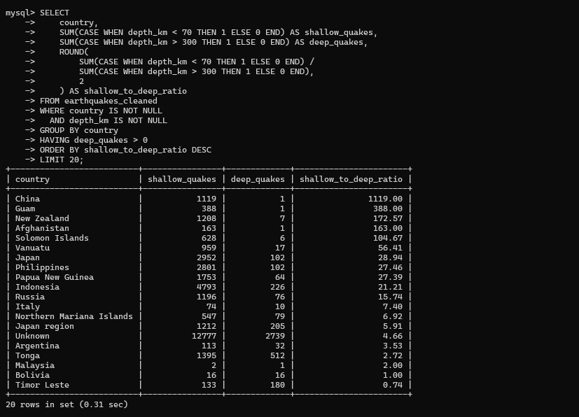

27. Find the average magnitude difference between earthquakes with tsunami alerts and those without.
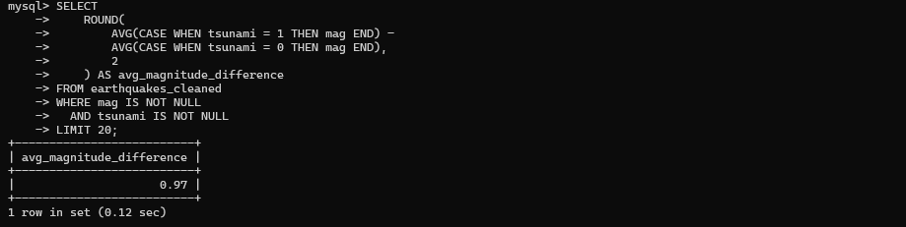

28. Using the gap and rms columns, identify events with the lowest data reliability (highest average error margins).
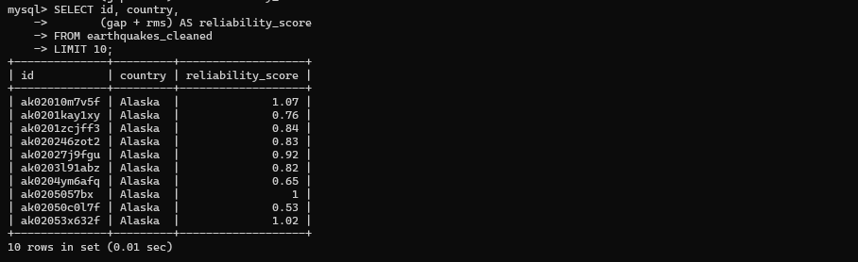

30. Determine the regions with the highest frequency of deep-focus earthquakes (depth > 300 km).
